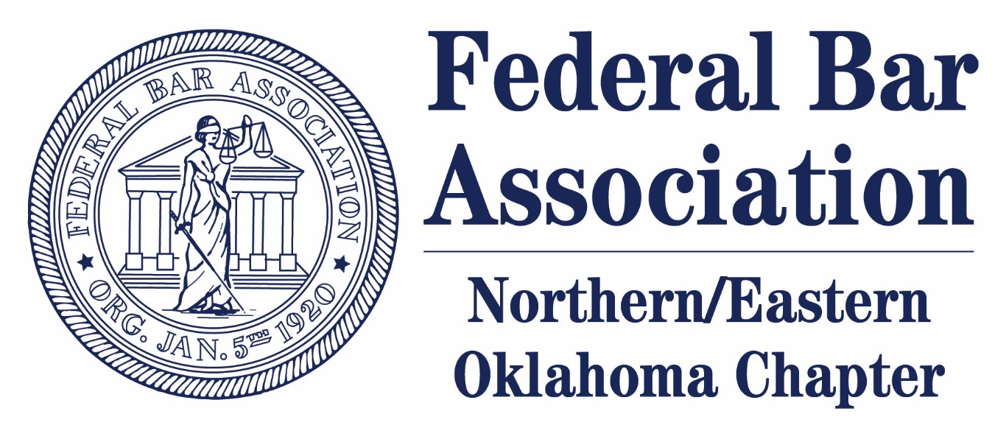

You are invited to attend a panel presentation featuring Chief U.S. District Judge John E. Dowdell, N.D. Okla.,
U.S. Magistrate Judge Suzanne Mitchell, W.D. Okla.,
U.S. District Judge Gregory K. Frizzell, N.D. Okla.,
Hope Forsyth, GableGotwals,
Caroline Guerra Wolf, Connors & Winters
moderated by Dean Lyn Entzeroth

“WHY FBA?”
An informational session about the Northern/Eastern Oklahoma Chapter’s TU Law Student Division and the benefits that joining the FBA confers

February 26, 2020
4:30 – 5:30 p.m.
Classroom 203
The University of Tulsa College of Law
Reception to follow in the Pit
All Chapter members invited, please RSVP at
jamie-lewis@utulsa.edu
Not a member? Become one HERE --
https://members.fedbar.org/eweb/DynamicPage.aspx?WebCode=LoginRequired&expires=yes&Site=FBA

