Arctic Transportation Infrastructure and Transportation Security

Friday, February 17, 2017 • 12:00–1:00 p.m.
United States Department of Transportation • 1200 New Jersey Avenue, SE, Rooms 8-9-10 Washington DC 20590

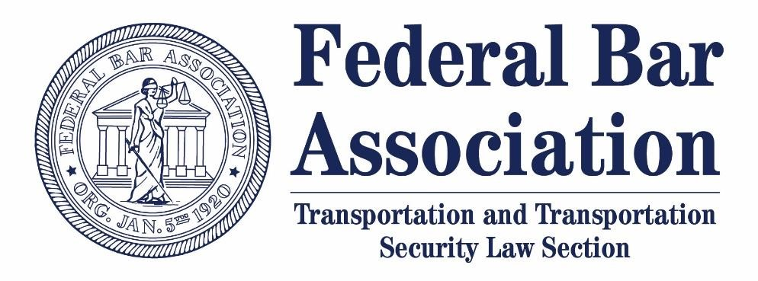
Please join the Transportation and Transportation Security Law Section for a discussion on developments in arctic transportation infrastructure and arctic transportation security.

Moderator:
- Shakira Mack, D.C. Representative, Denali Commission
Panelists:
- Dr. Alyson Azzara, International Trade Specialist, Office of International Activities, Maritime Administration
- Joel Neimeyer, Federal Co-Chair, Denali Commission
- Christopher T. “Kip” Tourtellot, Attorney-Advisor, Office of International Law, U.S. Department of Transportation

To attend, please RSVP to Josh Albertson. For those who cannot attend in person, a call-in number will be distributed upon registration.

