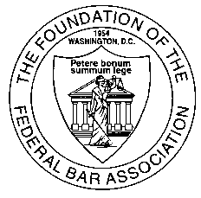
Fellows of the Foundation of the Federal Bar Association
Silent Auction Donation Form
Thank you for your donation to the Foundation Fellows Silent Auction. Please return this form by August 18, 2014 for inclusion in the online auction catalog. Please submit a completed form along with the item(s) that you are donating and include any photos, marketing materials, certificates, etc. All auction items will be listed in the online auction catalog that will be available on the Foundation’s website at www.fedbar.org/foundation prior to the FBA’s Annual Meeting and Convention on September 4-6, 2014 in Providence, RI.

Please send materials to:
Foundation Fellows Silent Auction
1220 N Fillmore St., Ste. 444
Arlington, VA 22201
Email: foundation@fedbar.org
Fax: (571) 481-9090
Please complete all fields below and submit form by August 18.

Donation Name: Click here to enter donation name.
Actual Value: Click here to enter actual value.
Description of Donation: (Please include a one paragraph description of the item being donated. If additional information is available online, please include a link to the appropriate website.)
Click here to enter description of donation.
Click here to choose yes or no. Digital photos provided (email to foundation@fedbar.org)
Click here to choose yes or no. Digital photos available online at Click here to enter website.
Valid dates (if applicable): Click here to enter a date. to Click here to enter a date.
Restrictions (if applicable): Click here to enter restrictions.
Included with item: (examples: free parking, transportation, meals, etc.) Click here to enter included items.

Donor Information
Primary donor name: Click here to enter primary donor name.
Secondary donor name: Click here to enter secondary donor name.
Contact person: Click here to enter contact person if different than primary donor.
Email address: Click here to enter email.
Address: Click here to enter address.
City, State, and Zip: Click here to enter city, state, zip.
Phone: Click here to enter phone.
Fax: Click here to enter fax.

