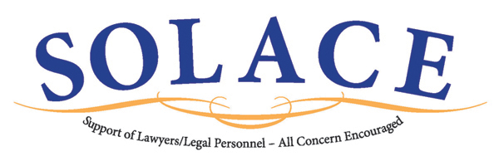

SAMPLE LETTER FROM CHAPTER PRESIDENT
OR SOLACE LIAISON TO CHAPTER MEMBERS

Dear [FBA Chapter Member]:
I am pleased to announce that our FBA Chapter is joining with other FBA Chapters around the country to provide a new benefit to our members through a program called “SOLACE”. SOLACE stands for "Support of Lawyers/Legal Personnel--All Concern Encouraged.” SOLACE provides a way for the FBA legal community to reach out in small, but meaningful and compassionate ways, to FBA members and those related to them in the legal community who experience a death, or some catastrophic event, illness, injury, or other personal crisis. District Court Judge Jay Zainey and an attorney, Mark Surprenant, both from New Orleans, originally developed the SOLACE program 13 years ago after Mark’s wife sustained a brain aneurysm. She recovered with the help of family members and friends, and SOLACE was born out of that experience. Recently, our National FBA President, Judge Michael Newman, made the SOLACE program one of his national priorities for the FBA.
So, how does SOLACE work? If you, a family member, or anyone related to you in the legal community (judges, lawyers, court personnel, paralegals, legal secretaries and their families) is in need of assistance because of a catastrophic event, illness, injury, or other personal crisis, the requesting person merely needs to fill out and submit electronically a SOLACE Request Form, or the requesting person can send an email identifying the need directly to our Chapter SOLACE Liaison, [Name of Liaison], at the following email address: solace@fedbar.org. There is absolutely no cost to participate in the SOLACE program.
Once a request is received, it is quickly reviewed by our Chapter SOLACE Liaison and/or FBA National SOLACE Coordinators and distributed to FBA members in our area or in other areas of the country where the need is most likely to be met. In the history of SOLACE, there has never been a request which did not receive a response.
No request is too big or too small. Over the years, the SOLACE program has helped numerous individuals by handling a wide variety of requests. Examples of past requests and responsive help include securing a medical evacuation airlift from a foreign country, donating furniture to a solo practitioner whose office was consumed by a fire, contributing frequent flyer miles or hotel points for families who cannot afford the travel costs associated with medical treatment, volunteering to care for the dog of an individual who was away from home while receiving cancer treatment, providing a family with meals, lodging, assistance with grocery shopping or child care, or providing non-legal information—whatever the situation may warrant. [SOLACE does not, however, handle requests for money.]
How can you help? As an FBA member, you automatically will receive SOLACE information via email, either from the FBA National Office or from our Chapter SOLACE Liaison, if a request for assistance is received that could be addressed by FBA members in our area. The SOLACE email notification will describe the need and how you can help. If you want to help, you respond. If you choose not to participate in SOLACE, you can unsubscribe from the SOLACE email service at any time by simply clicking on the “Unsubscribe” button or by informing the Chapter SOLACE Liaison that you wish to unsubscribe.
Please note that all SOLACE requests are handled as discreetly as possible. In normal circumstances, the only parties who will know the identity of a person requesting help are the SOLACE coordinators and the individuals offering help. Likewise, if you are offering to help meet a request, the only parties who will know your identity are the SOLACE coordinators and the individual seeking help.
For further information about SOLACE, feel free to contact [NAME], our Chapter SOLACE Liaison at [Email address and/or phone number] or visit the FBA SOLACE Webpage. Personally, I am very excited about the SOLACE initiative, and I am proud that our Chapter will participate and offer this benefit to our members. Working together, helping one another, we can make a lasting difference.

Sincerely,

[Chapter President or SOLACE Liaison]

