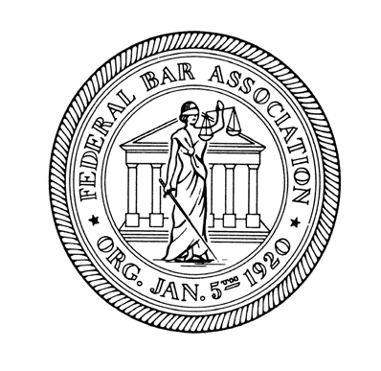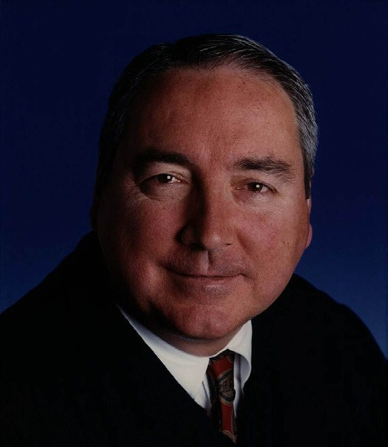
Spring 2014
FBA South Florida Chapter Newsletter
FEDERAL BAR ASSOCIATION
SOUTH FLORIDA CHAPTER
President
President-Elect
First Vice-President
Second Vice-President
Treasurer
Secretary
Director of IT and
Immediate Past- President and
Brett A. Barfield
Jeffrey B. Crockett
Alaina Fotiu-Wojtowicz
Celeste Higgins
Robin C. Kaplan
David O. Markus
Edward J. O’Donnell
Hon. Peter R. Palermo
Eduardo I. Sanchez
Clayton P. Solomon
Michael Tarre
David S. Weinstein
In This Issue
Federal Court Orientation .............................................................2
Membership Update ......................................................................3
Update from the National Government Relations Committee ....3
Bankers Club Luncheon Series .....................................................4
Upcoming Events ..........................................................................4
Law Student Events ......................................................................4
FBA Awards & Installation Dinner ..............................................4
33rd Federal Judicial Reception ....................................................2
Mindfulness CLE ..........................................................................2
A Message from the President ......................................................2
Law Clerks/ Young Lawyers Committee .......................................3
Women Lawyers Initiative ............................................................3
CPA Joins FBA ..............................................................................3
Honorable K. Michael Moore to Become Chief Judge
On July 1, 2014, the Honorable K. Michael Moore I also expect to work closely with our becomes Chief Judge of the United States District non-Article III judicial officers,
Court for the Southern District of Florida, taking bankruptcy and magistrate judges, as well over for current Chief Judge Federico A. Moreno. as the Clerk of Court and the Chief U.S.
Probation Officer. Together we share a
Moore earned a B.A. in Economics from Florida State common mission of operating the Court
University and a J.D. from Fordham Law School, smoothly, which means ensuring that
before embarking on a career in public service. After jurors, lawyers and the general public who
graduating from Fordham, Judge Moore served as an enter our courthouse, are welcomed,
Assistant United States Attorney respected and secure.
in the Southern and Northern The Chief Judge also oversees a Districts of Florida. In 1987, large organization of dedicated, Judge Moore was appointed loyal and hardworking
United States Attorney for the employees. I aim to ensure that Northern District of Florida by our employees have a clear President Reagan. Then, in 1989, understanding of performance President George H. W. Bush expectations, are provided with appointed Judge Moore to the necessary resources and Director of the United States training, have opportunities for Marshals Service, making him the advancement and understand first presidentially appointed that our judges appreciate their director of our nation’s oldest law Honorable K. Michael Moore, contribution to our common enforcement agency. In 1992, U.S. District Judge pursuit.”
President Bush appointed Judge Moore to his current
W hen Chief Judge Moreno was asked for position on the District Court. his thoughts on his successor, he had this to
W hen asked to comment on his goals in his new role say: “Judge Moore will make a great Chief as Chief Judge, Judge Moore stated: “It is important Judge. His prior roles as Director of the
to remember that the district court acts on most Marshals Service and United States administrative matters as a body. Consequently, a Attorney demonstrate that he knows how chief judge’s goals represent the collaborative and to succeed in a management position. As a collective goals of all of the court’s judges. It will be colleague, Judge Moore has always
my responsibility to communicate timely and accurate sacrificed for the good of the Court. information to my colleagues, so that we can make W henever a judge needs help, for whatever informed decisions on administrative matters. I will reason, Judge Moore is the first to
listen for ways to relieve my colleagues of burdensome volunteer. I am certain that he will administrative responsibilities, where appropriate, continue to put the Court first as Chief.” and support them in carrying out their judicial
responsibilities.
2013-2014 OFFICERS

Ana Maria Martinez Candace R. Duff Oliver A. Ruiz Benjamin Brodsky Gerald J. Houlihan
Barbara N. Papademetriou

Russell Koonin Social Media Bernard Pastor
National Delegate EXECUTIVE BOARD Jacqueline Becerra
Michael Caruso Wilfredo Fernandez Rachel Furst
Kevin P. Jacobs

David S. Mandel

Hon. John J. O’Sullivan

William V. Roppolo

Vanessa Snyder

Stephen Warren

Hon. Kathleen M. Williams
Ryan C. Zagare

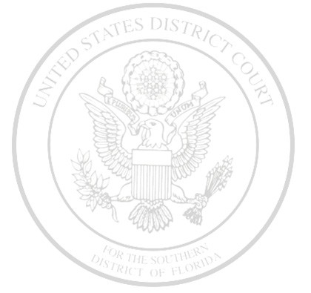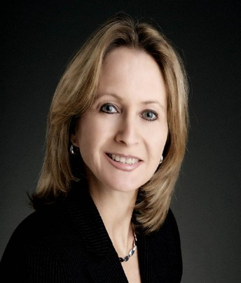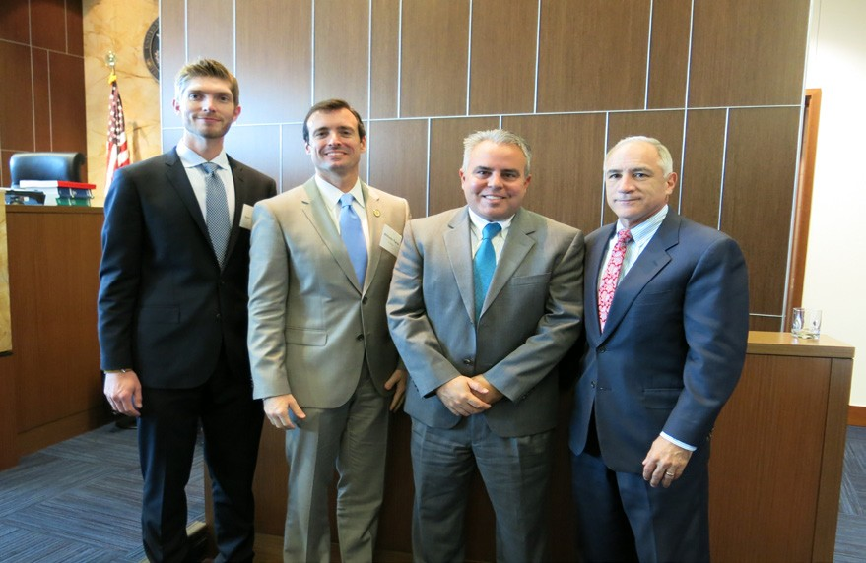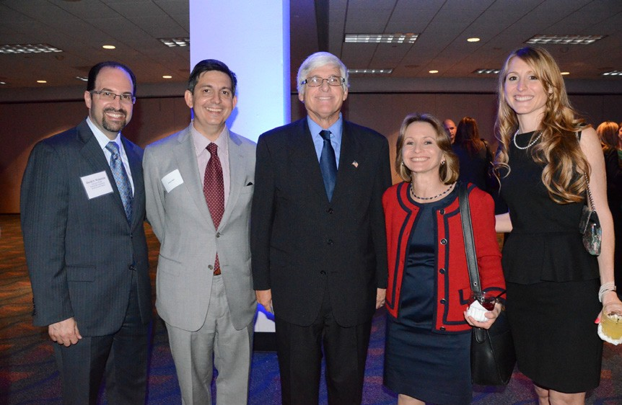
FBA South Florida Chapter Newsletter
Spring 2014
Federal Court Orientation. In January, the Chapter
hosted its second annual Federal Court Orientation program for newly admitted lawyers. The event was hosted in the chambers of U.S. District Judge Robert N. Scola, Jr. and featured three panel presentations. The first
33rd Federal Judicial Reception. The 33rd Annual
Judicial Reception on February 27, 2014 was another huge success! We had a tremendous turnout, including many members of our federal judiciary, lawyers from diverse practice areas, law clerks, and law students.
For the
second year in a row, we were in the larger upstairs room at the Hyatt, with gorgeous views of the river.
panel was
comprised of Senior District Judge Paul C. Huck, District Judge Kathleen M. Williams,
and Magistrate Judge Edwin G. Torres, and focused on civil
pretrial matters, professionalism, and legal writing. The second panel was comprised of District Judge Scola, U.S. Attorney Wifredo Ferrer, and Chief Assistant Federal Defender Hector Dopico, and focused on trial practice. The final panel was hosted by the court’s IT staff and addressed the latest courtroom technology. The presentations were followed by lunch with the judges.
Throughout the evening attendees mingled with one another,
seizing the opportunity to catch up with known acquaintances and meet new ones as well. Our local law school student members assisted in signing up new Chapter members at the event. If you have any comments or questions for next year’s event, please do not hesitate to send an email to our Reception Committee chair at brett.barfield@ hklaw.com. We hope to see you next year!

President’s Message. The South Florida Chapter is now the 5th largest in the Federal Bar Association. As our membership grows, our activities have also grown in type and number. As always, the Chapter’s annual Federal Judicial Reception was enjoyed by hundreds of attorneys and judges.

The Chapter is committed to the future of federal practice, with activities for law clerks, young lawyers, and law students. This year, the Chapter co-sponsored a discussion on mindfulness and a symposium on significant leading federal district court decisions. The Chapter’s women’s initiative continues to bring phenomenal speakers on cutting-edge topics. Our members also continued to enjoy networking
and hearing great speakers at our Bankers Club luncheons.

In the summer, we are looking forward to the “Board Room” lunches, which provide an opportunity to talk with leaders in the federal practice community in a small informal setting. FBA members attend for free. We also look forward to a summer event for young lawyers and another women’s initiative event.

Please visit our new Chapter website at www.f ba-sdf la.org. There is a new section on FBA publications, with the aim of helping FBA members publish in the Federal Lawyer magazine or the FBA section newsletters. We also encourage FBA members to sign up on the new pro bono contact page of the U.S. District Court website.

Finally, our Chapter is grateful for the dedicated service by Judge Moreno as Chief Judge, and for Judge Moreno’s support of the FBA. Our Chapter looks forward to a great relationship with Judge Moore, who will become Chief Judge this summer. President, Ana Maria “Ani” Martinez.

2

Mindfulness CLE. On February 6, 2014, the DCBA/FBA South Florida Chapter’s Mindfulness in the Law Joint Task Force, The University of Miami Mindfulness in Law Program, and Berger Singerman LLP, hosted a CLE program titled, “Raising the Bar: A Mindful and Ethical Start for the New Year.” It was attended by more than 130 judges and attorneys. Panelists included U.S. Senior District Judge Alan S. Gold, Dr. Amishi Jha, a neuroscientist and professor at UM, U.S. Magistrate Judge Chris M. McAliley, Tony Recio, Esq. of Weiss Serota Helfman Pastoriza Cole & Boniske, and Prof. Scott Rogers, founder of the UM Law School’s Mindfulness in Law Program. The panel addressed neurological, health, and other benefits of maintaining a mindfulness practice, and ideas for integrating mindfulness in the practice of law.

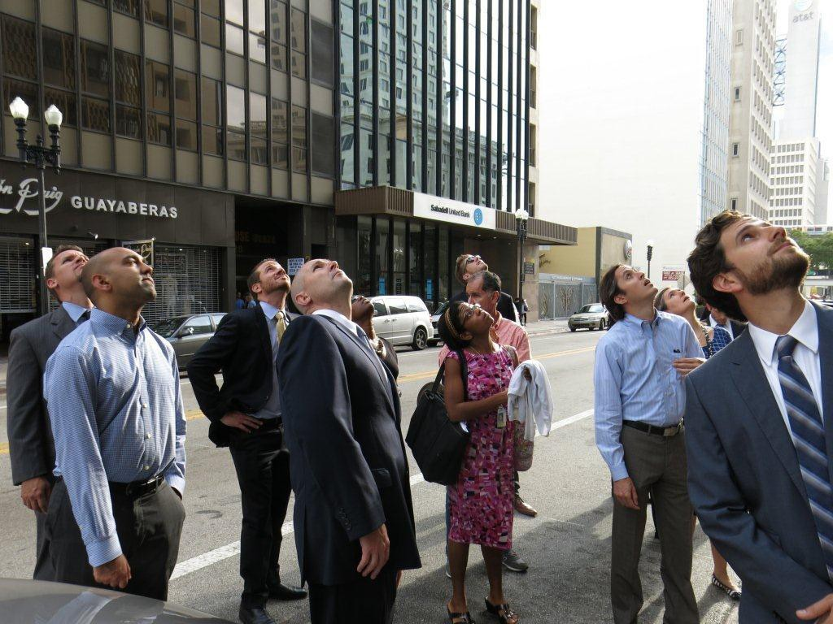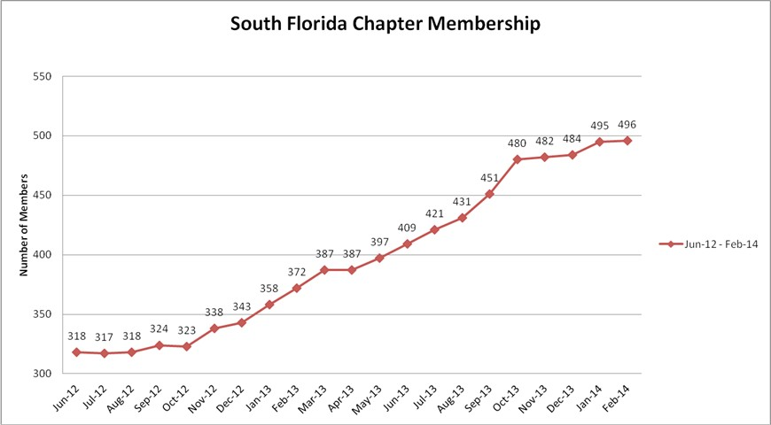
FBA South Florida Chapter Newsletter
Spring 2014
Law Clerks / Young Lawyers Committee. This
Spring, the Law Clerks/Young Lawyers Committee hosted two events. In March, we partnered with the FBA Student Chapter at the University of Miami School of Law to host a “Meet the Law Clerks” Lunch at the Miami-Dade County Attorney’s Office in downtown Miami. The event
provided law students an opportunity to meet federal law clerks and to speak with them about their work and the process of applying for clerkships. The luncheon began with a welcome from County Attorney Robert Cuevas and First Assistant County Attorney Abigail Price-Williams.
great architecture found in downtown Miami. Following
the tour, law clerks congregated at La Loggia for a networking happy hour.
In April, we joined HistoryMiami for an informational
event and happy hour. Dr. Paul George of Miami-Dade College and HistoryMiami treated attendees to an historical tour of Flagler Street, with an emphasis on the
Women Lawyers Initiative. The Women Lawyers Initiative has been busy in recent months. In November, the WLI
hosted a sold out CLE on social media and the courtroom. The event was well received and participants have requested a follow-up presentation in 2014. In March, the WLI hosted a CLE on trial graphics and technology. The speaker was Kerri Ruttenberg, a national authority on trial graphics. Ms. Ruttenberg gave a two-hour program discussing the effective use of technology and graphics in the courtroom.
Bruce Yasukochi, CPA Joins FBA. As the South Florida Chapter has grown in
members and activities, we are fortunate to have an outstanding CPA, Bruce Yasukochi, helping the FBA pro bono! Mr. Yasukochi has assisted the Chapter with tax returns, financial statements, record keeping, profit and loss analysis, and general advice for streamlined and excellent management of the Chapter’s finances. Mr. Yasukochi is familiar with lawyers and federal court. He is a practice leader in Cherry Bekaert LLP’s fraud and forensics group. He has led many significant and complex fraud and internal corporate investigations. Mr. Yasukochi has many years of experience, including ten years at a Big Four Accounting Firm.
Chapter Membership Increases to 496! Our Chapter continues
to grow at a rapid pace. Since June 2012, our membership has increased from 318 members to 496 members, a 56% increase. Our Chapter is now the 5th largest in the country. Help us break the 500-member barrier by encouraging your colleagues to join today.
Update From the National
Government Relations Committee.
On April 25, as part of FBA Capitol Hill Day in Washington, D.C., FBA delegations met with nearly all Senators (or their respective staff) on the Senate Judiciary Committee.
FBA urged support for the Federal Judiciary’s imminent request for an emergency supplemental appropriation to mitigate the impact of sequestration. The appropriation will assist in reducing the dire funding situation faced by Federal Defender Offices. FBA advocates also sought prompt Senate consideration of pending judicial nominees. Of the 87 vacancies as of April 2014, 36 are characterized by the Administrative Office
of the U.S. Courts as “judicial emergencies.”
3

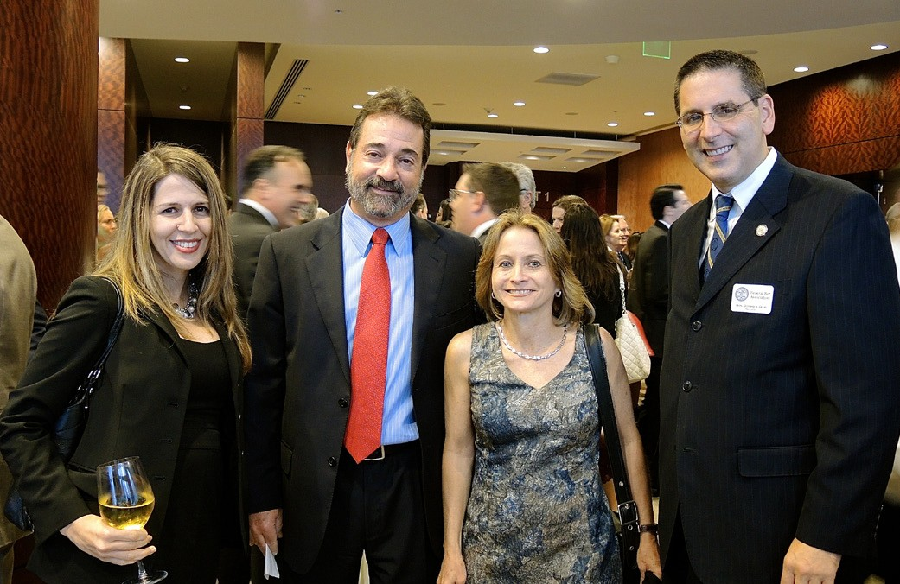
FBA South Florida Chapter Newsletter
Spring 2014
Bankers Club Luncheon Series. Our Bankers Club Luncheons invite a distinguished
guest or panel to discuss timely issues, and are an opportunity for members of the local bar to network and mingle. Below are highlights from our most recent lunches.
At our January luncheon Robert E. O’Neill spoke about the trends in criminal cases
going to trial in the Southern and Middle Districts of Florida. Mr. O’Neill served as the
United States Attorney for the Middle District of Florida from 2007-2008 and again from
2010-2013.
●●
In March, U.S. District Judge Kenneth A. Marra gave a fascinating talk about the role of
jurors, specifically analyzing the ramifications of a six versus twelve-person jury. Judge Marra also fielded questions from both the live audience and from e-mails to our moderator.
●●
Finally, in April we hosted a panel discussion titled, “The Federal Grand Jury.” The
panelists were U.S. District Judge Donald L. Graham, U.S. Magistrate Judge Andrea M. Simonton, Supervisory AUSA Peter Forand, and defense attorney Howard Srebnick. AUSA Robert Watson moderated the panel discussion, which focused on various aspects of the grand jury process.
Law Student Events. Our Chapter was involved in two great law student events in March. On March 20, the FIU Law student chapter hosted an event titled, “Pathway to a Clerkship,” at the FIU College of Law. The panel was comprised of U.S. Circuit Judge Adalberto J. Jordan and U.S. Magistrate Judge Andrea M. Simonton. FIU Law Dean R. Alexander Acosta and Bernie Pastor also joined the judges and students at a reception after the talk. On March 16, a group of law students and lawyers met to ride for a cause at FlyWheel in Miami Beach. Attendees, who each generously donated $25 to Legal Services of Greater Miami, Inc., participated in an energetic cycling ride followed by a luncheon sponsored by the University of Miami.
FBA Awards & Installation Dinner. This year’s FBA Awards & Installation Dinner took place on October 25, 2013, at the JW Marriot Marquis. The dinner reached maximum capacity and exceeded previous attendance records with over 300 guests in attendance. U.S. District Judge Peter Palermo gave the traditional invocation and Federal Public Defender Michael Caruso led the Pledge of Allegiance.
●●
Outgoing Chapter President Bernie
Pastor began by sharing some of the Chapter’s accomplishments over the last year. Bernie then introduced
our United States Attorney, Wifredo
Ferrer, who presented the Honorable Stanley Marcus with the Edward B. Davis Award for Service to the Federal Bench & Bar, the Chapter’s highest honor. The Award is given to a judge or lawyer who has exemplified the FBA’s values of excellence and service to the community, the federal bench, and the federal bar.
Bernie then introduced the Chapter’s 2013-14 President, Assistant U.S. Attorney Ana Maria
Martinez. After Chief Judge Moreno swore in Ani, the other new officers, and the executive board, Ani introduced national FBA President and U.S. District Judge Gustavo Gelpi. Judge Gelpi commended the South Florida Chapter for its accomplishments and the several awards we received this year. Ani ended the evening by expressing the Chapter’s gratitude for Bernie’s service throughout the previous year.
4

Upcoming Events

Bankers Club Luncheon U.S. Magistrate Judges Alicia M. Otazo-Reyes and Alicia Valle
May 14, 2014

Attorney/Law Student Networking Event Batch Gastropub
June 10, 2014

Boardroom Lunch Eric I. Bustillo, Regional Director of the Miami Regional Office of the U.S. SEC
Holland & Knight
June 12, 2014

Boardroom Lunch Judge Robert N. Scola, Jr. July 2014

Boardroom Lunch
August 2014

Boardroom Lunch
September 2014

FBA Women Lawyers
Initiative
Fall 2014

Annual Awards & Installation Dinner Fall 2014

Visit our new website at www.f ba-sdf la.org

Become a mentor today!

Email Yaniv Adar at yadar@homerbonner.com

Newsletter Editors

Clayton Solomon
Stephanie Casey

Have a suggestion for future newsletter content?

Email the committee at federalbar. southflorida@gmail.com
Attn: Newsletter Committee

